**To view all options:**

git config --list

**Set up aliases**

$ git config --globle alias.co checkout

error: unknown option `globle'

usage: git config [options]

Config file location

--global use global config file

--system use system config file

--local use repository config file

-f, --file <file> use given config file

Action

--get get value: name [value-regex]

--get-all get all values: key [value-regex]

--get-regexp get values for regexp: name-regex [value-regex]

--replace-all replace all matching variables: name value [value_rege

x]

--add adds a new variable: name value

--unset removes a variable: name [value-regex]

--unset-all removes all matches: name [value-regex]

--rename-section rename section: old-name new-name

--remove-section remove a section: name

-l, --list list all

-e, --edit opens an editor

--get-color <slot> find the color configured: [default]

--get-colorbool <slot>

find the color setting: [stdout-is-tty]

Type

--bool value is "true" or "false"

--int value is decimal number

--bool-or-int value is --bool or --int

--path value is a path (file or directory name)

Other

-z, --null terminate values with NUL byte

# [How to compare two documents in Microsoft Word](http://www.simplehelp.net/2010/09/17/how-to-compare-two-documents-in-microsoft-word/)

OfficeWindowsMicrosoft Word is an excellent program to manage your documents. With Microsoft Word, not only can you create and edit documents, but you can even compare two documents for differences. For example, if you are a student and have two versions of the same essay, you can easily view and compare the two docs.

If you are unaware of this feature, follow this tutorial and you’ll be able to compare and determine the differences between your documents within minutes.

1. Open Microsoft Word and go to **Review** > **Compare**.

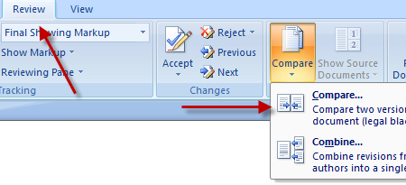

1. It will open the **Compare Document** dialog box where you can browse the documents you want to compare. In the **Original document** field, select the original document and from the **Revised document** field, select the document in which you made changes.

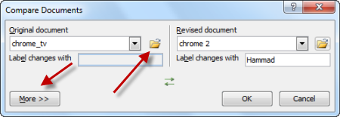

1. Click on **More** to view more comparison settings and check what data in the documents you want to compare. Check the fields and once you are satisfied, click **OK**.

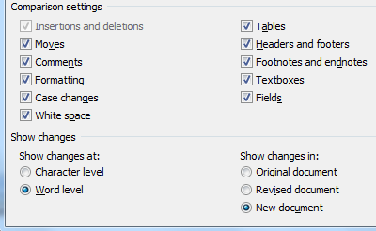

1. This will open a window that displays the comparison results. It will have a series of columns and panes. The ones to focus on are **Compared Document**, **Original Document** and **Revised Document**.

[[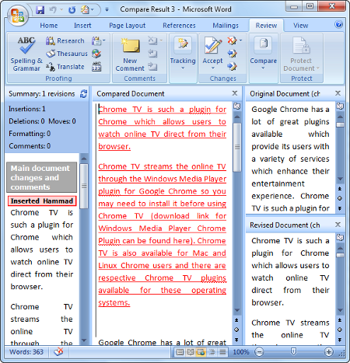](http://www.simplehelp.net/2010/09/17/how-to-compare-two-documents-in-microsoft-word/%3Cimg%20src=)  
click to enlarge](http://www.simplehelp.net/2010/09/17/how-to-compare-two-documents-in-microsoft-word/%3Cimg%20src=)

1. In the **Compared Document** field, the changes between the two documents will be highlighted for you.

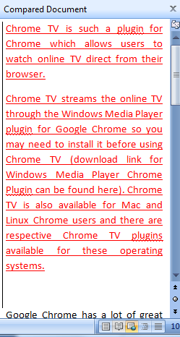

1. This way you can compare two documents and can find all of the differences.